UNIT-2 (COMPUTATIONAL THINKING AND PROGRAMMING)

introduction to python
Python is a high-level, interpreted, general-purpose programming language
. It was created by Guido van Rossum and first released in 1991, with its name inspired by the British comedy show Monty Python's Flying Circus. Python is known for its clear, readable syntax and extensive collection of libraries, which make it a highly versatile language for both beginners and experienced developers.
Key features
- Easy to learn and use: Python's syntax is designed for readability and resembles plain English, using indentation instead of curly brackets to define code blocks.
- Interpreted language: Python code is executed line-by-line by an interpreter rather than being compiled. This speeds up the development process and simplifies debugging by pinpointing errors immediately.
- Dynamically typed: You do not need to declare variable types beforehand, as Python determines them at runtime. This allows for greater flexibility and faster prototyping.
- Open-source: Python is free to use and distribute. Its open-source nature, maintained by the Python Software Foundation and a large, active community, encourages continuous improvement.
- Cross-platform compatible: Python code can run on different operating systems, including Windows, macOS, and Linux, with minimal or no changes.
- Multi-paradigm: It supports multiple programming styles, including object-oriented, procedural, and functional programming.
- Extensive libraries: The standard library is vast and includes modules for everything from web services to operating system interfaces. A massive ecosystem of third-party libraries is available through the Python Package Index (PyPI).
Common applications
Due to its versatility, Python is used in a wide range of fields.
- Web development: Used for server-side web applications with frameworks like Django and Flask.
- Data science and machine learning: A leading language in these fields, leveraging libraries such as NumPy, Pandas, and TensorFlow to handle data analysis, visualization, and the development of AI algorithms.
- Automation and scripting: Its simple syntax makes it ideal for writing scripts to automate repetitive tasks, such as managing files, web scraping, and sending emails.
- Software development: Used for software development and support tasks like build control, bug tracking, and automated testing.
- Desktop GUI applications: Supports the creation of desktop applications using toolkits like Tkinter and PyQt.
- Game development: Utilized in the creation of video games, particularly 2D games, with libraries like Pygame.

Understanding Hello World Program in Python

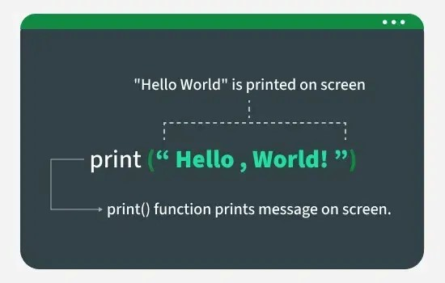
# This is a comment. It will not be executed.
print("Hello, World!")

Output
Hello, World!
How does this work:
- print() is a built-in Python function that instructs the computer to display text on the screen.
- "Hello, World!" is a string, which is a sequence of text. In Python, strings are enclosed in quotes (either single ' or double ").
- Anything after a # symbol is a comment. Python ignores comments, but they are useful for explaining code to human readers.

EXECUTION MODES IN PYTHON
Python primarily has two modes of execution:
- Interactive Mode
- Script Mode
Interactive mode (REPL)
Interactive mode is a command-line environment where you can enter Python code one line at a time and see the results immediately. This environment is also known as a Read-Eval-Print Loop (REPL).
- How to use it:
  - Open a terminal or command prompt and type python (or python3 on some systems) and press Enter.
  - The prompt will change to >>>, indicating you are in the Python shell and can start entering commands.
- Best for:
  - Quick tests and calculations: You can perform simple math or test small code without saving a file.
  - Learning and experimentation: It provides immediate feedback, making it a great tool for beginners to learn Python syntax and features.
  - Debugging: You can use it to test a specific function or check the value of a variable during a debugging session.
- Limitations:
  - The code is not saved, so you lose your work when you exit the session.
  - It is not suitable for writing large, multi-line programs.
Script mode
In script mode, you write a complete Python program in a text file and then use the Python interpreter to execute the entire file at once.
- How to use it:
  - Write your Python code in a file and save it with a .py extension (e.g., my_program.py).
  - From a terminal or command prompt, navigate to the directory where you saved the file.
  - Run the script by typing python my_program.py (or python3 my_program.py on some systems).
- Best for:
  - Developing applications: It is the standard method for building larger, more complex applications that require multiple lines of code.
  - Reusability: You can save the script and run it multiple times without re-typing the code.
  - Automation: Scripts are ideal for automating repetitive tasks.
- Tools for script mode:
  - Integrated Development Environments (IDEs): IDEs like PyCharm and VS Code offer features like syntax highlighting, code completion, and a "Run" button to execute scripts.
  - IDLE: Python's default IDE, IDLE, also provides a text editor to write and run

